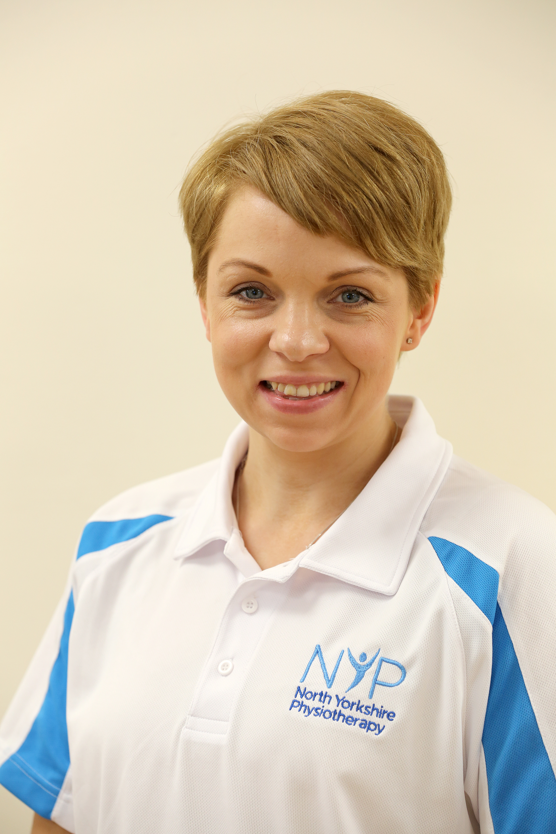

Hannah Holloran

Senior Physiotherapist